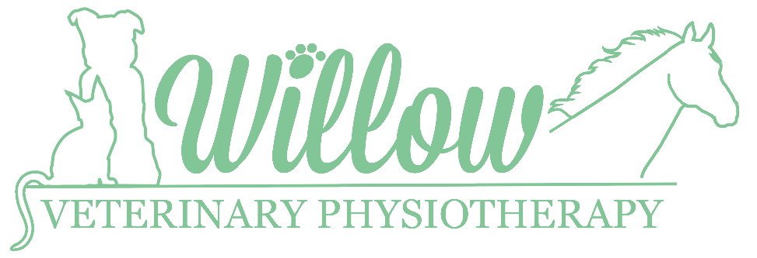
Owner Consent Form

Owner Details
Name:
Address:

Email:

Telephone:

Animal Details
Age:

Species:

Name:
Breed:

Neutered:

Sex:

Veterinary Details
Practice Name:
Veterinary surgeon:

Address:

Email:

Telephone:

Case History

Medical History: (Please provide details of any previous conditions)

Yes ☐ No ☐
Do you give Willow Veterinary Physiotherapy consent to contact your Veterinary Surgeon if during assessment, an underlying condition or injury is identified?

Declaration
I confirm that the information given above is true and accurate to the best of my knowledge. I give my consent for Willow Veterinary Physiotherapy to treat my animal in accordance with their professional judgement. I accept that where an unknown injury or underlying condition is identified, treatment will stop until my vet has undertaken a clinical assessment and delegated the need for physiotherapy. By signing this consent form, I agree to Willow Veterinary Physiotherapy’s terms and conditions which can be viewed on their website.

Print Name: …………………………………………………. Signed: …………………………………………….
Date: …………………………………………………………
Rebecca Flecknor Bsc (Hons), Veterinary Physiotherapist
Tel: 07999452206 Email: Willowvetphysio@gmail.com

