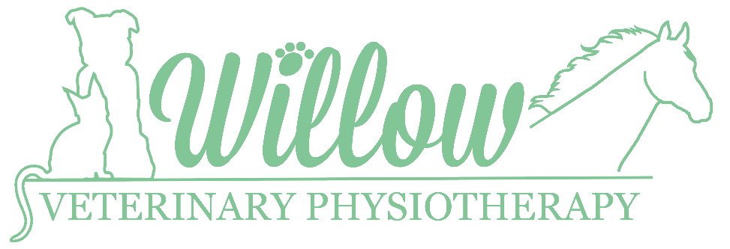

Veterinary Consent Form

Section A: Owner Details
Name:
Address:

Telephone:

Email:

Section B: Animal Details
Name:
Breed:

Species:

Age:

Sex:

Section C: For completion by the veterinary practice
Date:

Veterinary Surgeon’s Declaration: In my opinion, the above animal is in a suitable state of health to undergo Veterinary Physiotherapy

Name:

Email:

Telephone Number:

Address / Practice Stamp:

Reason for referral / relevant history:

Signature:

PLEASE EMAIL COMPLETED FORM AND ANY ADDITIONAL NOTES / DIAGNOSTIC IMAGING TO:
willowvetphysio@gmail.com
Tel: 07999452206

Rebecca Flecknor Bsc (Hons), Veterinary Physiotherapist
Tel: 07999452206

